Project Design Phase-II
Data Flow Diagram & User Stories
Date | 25 August 2026
Team ID | N/A
Project Name | HouseHunt
Maximum Marks

Data Flow Diagram (DFD):
A Data Flow Diagram represents how data moves through the HouseHunt platform. It shows the flow of information between Tenants, Landlords, Administrators, and the MongoDB database, showing how listings are created, moderated, searched, and booked.
Level 0 DFD – HouseHunt Context Diagram:
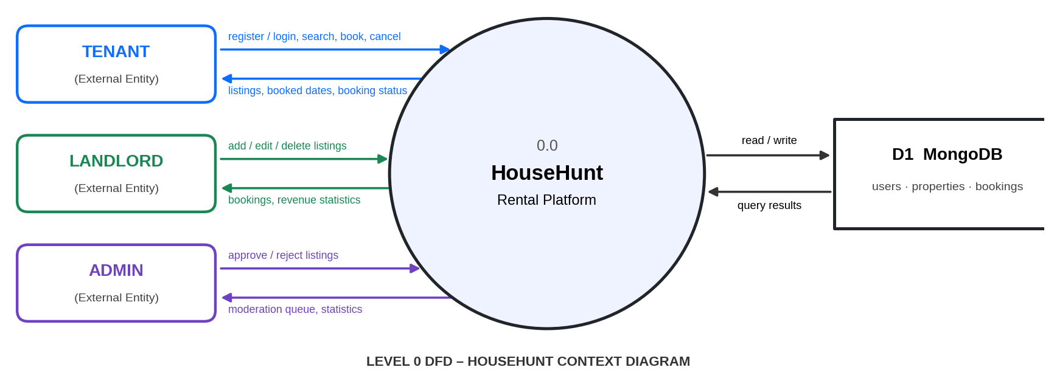
User Stories:
User Type | Functional Requirement (Epic) | USN | User Story / Task | Acceptance Criteria | Priority | Sprint
Tenant | Registration | USN-1 | As a tenant, I can register with my name, email, and password. | Account created; JWT returned | High | S-1
User | Authentication | USN-2 | As a user, I can log in with email and password to reach my dashboard. | Valid login returns JWT; invalid gets 401 | High | S-1
Landlord | Property Listing | USN-3 | As a landlord, I can add a property with details and a photo. | Listing saved as "pending" | High | S-2
Tenant | Search & Filter | USN-4 | As a tenant, I can search and filter by location, type, price, and amenities. | Approved listings only; paginated | High | S-2
Tenant | Availability | USN-5 | As a tenant, I can see already-booked dates on a property page. | Booked dates shown in calendar | Medium | S-3
Tenant | Booking | USN-6 | As a tenant, I can book a property for chosen dates. | Overlap rejected; total price computed | High | S-3
Tenant | Booking Management | USN-7 | As a tenant, I can view and cancel my bookings. | Status changes to "cancelled" | Medium | S-3
Landlord | Dashboard | USN-8 | As a landlord, I can view my properties, bookings, and revenue. | Stat cards and lists shown | Medium | S-4
Admin | Moderation | USN-9 | As an admin, I can approve or reject pending listings. | Only approved listings are public | High | S-4
User | Account Deletion | USN-10 | As a user, I can delete my account and its data. | Properties and bookings removed | Medium | S-5

